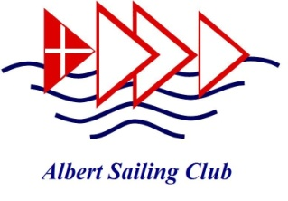
VISITOR REGISTER

NOTE: PEOPLE ARE NOT PERMITTED IN THE ALBERT SAILING CLUB UNLESS THE FOLLOWING CONDITIONS HAVE BEEN AGREED AND SIGNED PRIOR TO ANY VISIT.
ALSO ‘SIGN OFF’ PRIOR TO LEAVING THE CLUBROOMS

Name: ________________________________________
Address: ____________________________________________________________
Contact Phone number: __________________________________________
Email: __________________________________________

Date of Attendance at Club Premises: -- -- / -- -- / -- --
Time of Arrival: _________________
Time of Departure: _________________

To be completed prior to entry to the Club:
- I am aware of current government COVID19 requirements and agree to adhere to them including:
  - Personal responsibility for Personal Hygiene and Safety measures
  - Social distancing of 1.5 metres at all times
  - No congregation in groups >10

- I am not currently showing any symptoms of COVID19 infection nor have I had any recent known contact with anyone with COVID19. I agree that I will advise the Club immediately if I develop any symptoms or have close contact with an infected person following any visit to club premises.
- I understand requirements and limitations on use of clubrooms, and sailing arrangements.
- I will wipe down/sanitize club building and boatyard surfaces that I contact, including: Door handles, table tops, boatyard access points, the boat lifter and toilet areas.

Declaration: " I accept and agree to the current COVID19 rules and prescriptions of the Victorian DHHS and of Albert Sailing Club when attending ASC clubrooms.”
Signed: Dated:
* Parent or Guardian to sign on behalf of a child or youth under 18 years of age.

